BISMA AZAM BAJWA
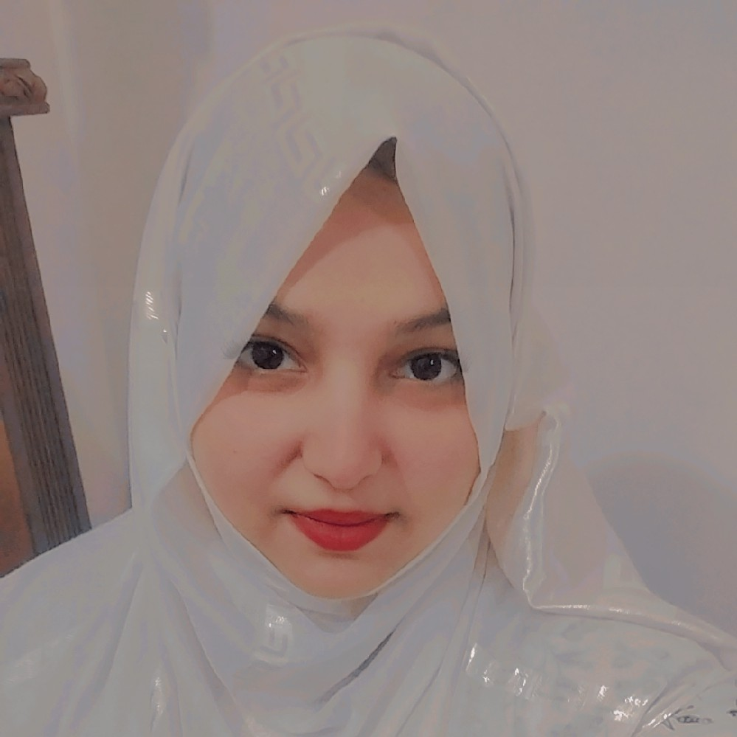
CONTACT  bismaazam05@gmail.com +923196022528
Pir Mehr Ali Shah Town Chakri Road Rawalpindi

OBJECTIVE

To secure a challenging position where I can utilize my customer service, dispatch coordination, communication, and administrative skills while contributing to the
organization's growth. A motivated and quick learner with experience in customer
support, remote operations, and team coordination, seeking an opportunity to deliver excellent results and continuously develop professionally.

EXPERIENCE
March 2019 - July 2020

March 2020 -
September 2022

Sales Executive (Remote) PZ Packaging US Compaign

Promoted and marketed PZ Packaging products across the US market during the COVID-19 pandemic.
Assisted in the sales and distribution of face masks to customers and businesses. Communicated with clients to understand their requirements and provide suitable product solutions.
Maintained strong customer relationships by ensuring timely responses and professional service.
Coordinated with the team to ensure smooth order processing and on-time deliveries.
Contributed to achieving sales targets through effective communication and customer engagement.

Teaching
Rulers Academy Lahore

Delivered engaging and well-structured lessons to Class 10th and Class 11th students (Arts Subjects).
Prepared lesson plans, assignments, quizzes, and examinations according to the curriculum.
Monitored students' academic progress and provided individual guidance to improve performance.
Maintained a positive and disciplined classroom environment to support effective learning.

September 2022 -
November 2023

12 February 2023 -
29 December 2024

January 2025 -
December 2025
Communicated regularly with students and parents regarding academic progress and classroom activities.
Assisted students in exam preparation by providing extra support and practice sessions.

Teaching
Kunzul Iman Academy Lahore

Taught Science subjects to Class 9th and Class 10th students following the prescribed curriculum.
Prepared lesson plans, classroom activities, assignments, quizzes, and examinations. Explained scientific concepts through practical examples to improve students' understanding.
Assessed students' academic performance and provided constructive feedback for improvement.
Maintained a disciplined and interactive classroom environment that encouraged active learning.
Guided students in exam preparation, helping them achieve improved academic results.
Customer Service (Remote) Zong SIM Pack

Provided professional customer support through inbound and outbound calls, resolving customer queries efficiently.
Assisted customers with SIM activation, package subscriptions, billing issues, and account-related services.
Handled customer complaints and ensured timely resolution while maintaining a high level of customer satisfaction.
Maintained accurate customer information and updated CRM records to ensure data accuracy.
Educated customers about available packages, promotions, and value-added services based on their needs.
Consistently met performance targets, including call quality, customer satisfaction, and productivity metrics.

Invigilator
Punjab And Government University

Supervised examination halls to ensure a fair, secure, and well-organized testing environment.
Verified candidates' identities and ensured compliance with examination rules and procedures.
Distributed and collected examination materials accurately and on time.
Monitored candidates throughout the examination to prevent malpractice and maintain discipline.
Assisted candidates with examination instructions while maintaining confidentiality and impartiality.

December 2025 -
May 2026

February 2024 -
January 2026

18 March -
Performed invigilation duties for LAT, CSS, PPSC, and other competitive examinations in accordance with official guidelines.
Chat support Customer and Drivers Dealing (Remote) Professional Safe Driver Dubai Company

Provided customer support through chat, ensuring prompt and professional responses to inquiries.
Coordinated with drivers to schedule pickups, deliveries, and transportation services efficiently.
Managed driver assignments, bookings, and route coordination to ensure timely service.
Resolved customer complaints, booking modifications, and service-related issues while maintaining high customer satisfaction.
Communicated effectively with customers and drivers to ensure smooth daily operations.
Maintained accurate booking records and supported operational efficiency through timely updates and coordination.
YouTube automation (Remote) YouTube Channels Handling

Managed YouTube automation channels from content planning to video publishing.
Conducted market and keyword research to identify trending topics and content opportunities.
Created engaging video scripts and coordinated AI-generated voiceovers for production.
Optimized video titles, descriptions, tags, and thumbnails to improve search visibility and audience reach.
Scheduled and published videos while maintaining a consistent content calendar.
Monitored channel performance using YouTube Analytics and implemented strategies to increase views, watch time, and subscriber growth.
Customer Handling (Remote) Car Dispatcher
Coordinated daily vehicle dispatch operations to ensure timely pickups and deliveries. Communicated with drivers, customers, brokers, and transport companies to manage schedules and resolve operational issues.
Assigned loads, tracked shipments, and monitored delivery status to ensure on-time performance.
Managed dispatch documentation, including load details, pickup and delivery instructions, and customer records.
Provided professional customer support through phone calls, emails, chat, and dispatch platforms.
Resolved customer concerns, scheduling conflicts, and service-related issues while maintaining high customer satisfaction.
Maintained accurate dispatch records and updated shipment information to support smooth workflow and operational efficiency.
Worked closely with the operations team to optimize routes, improve coordination,

and ensure seamless transportation services.

EDUCATION
2021

2023

2025

Matric with Science
Millat-e-Islamia Model High School Lahore A+
Intermediate (pre-medical) Army Public College Rawalpindi A
Associate Degree In Education University of Education Lahore A

SKILLS

MS Office(Word, Excel, PowerPoint)

Canva And Graphic Designing Expert

100%
80%

Video Editing Meta Business Suit Expert
100%
100%

Social Media Management & Growth
Effected Communication

100%
Effected Dealing Abilities
100%
100%

Qualities of Inbound And Outbound Calls
Abilities Good Teaching

80%
Chat support Customer Dealing
100%
100%

Quick Learner Remote Project & Operations Management
100%
100%

Teamwork Problem Solving & Decision Making
100%
100%

Strategic Planning & Execution Team Leadership, Delegation &
Performance Management
100%
100%

Time Management & Multitasking
100%

LANGUAGES

English - Professional Urdu - Native
Hindi - Basic Punjabi - Native

